Final Exam Part II
NOS 125 Mrs. Holley
Import method used: Imported the 2 tasks with error handling
task 1 installing packages
task 2 enabling the packages
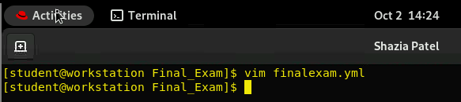
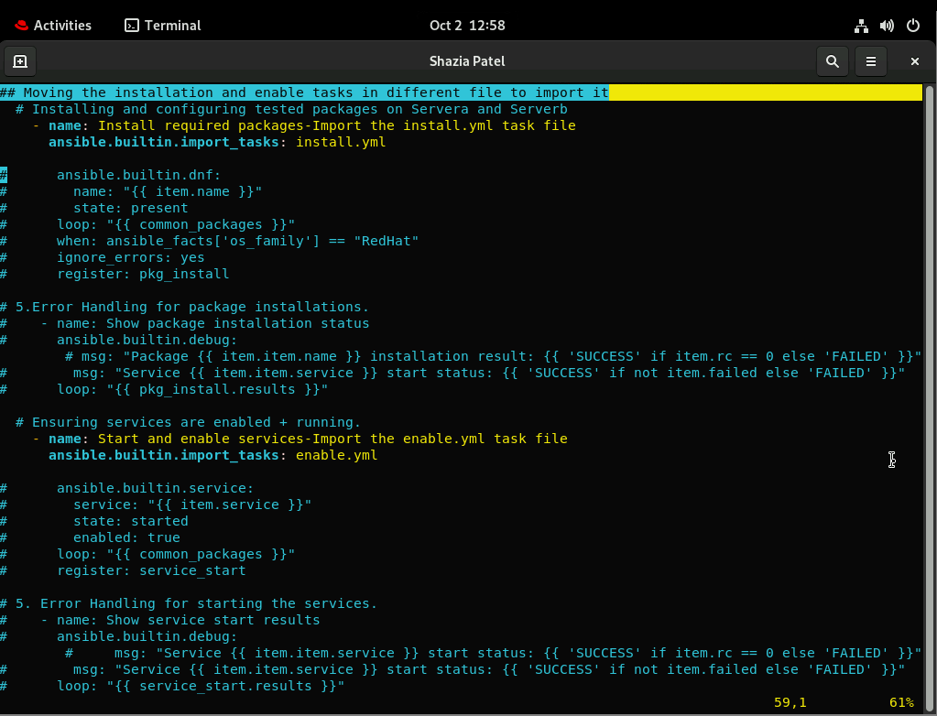

Install.yml
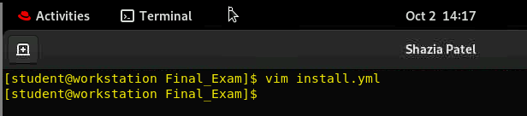
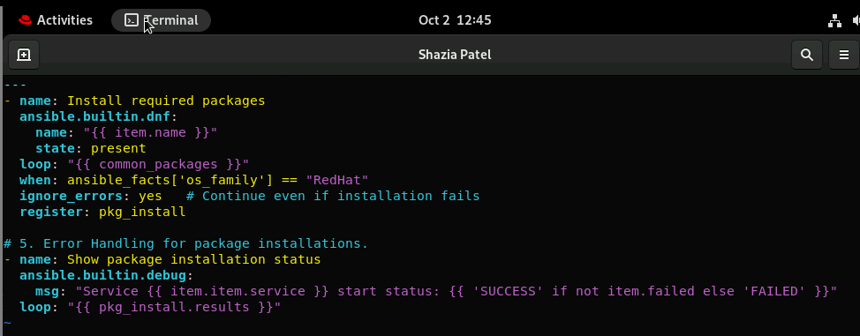
enable.yml
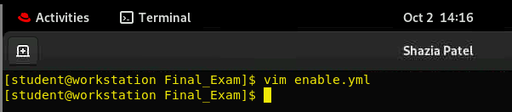
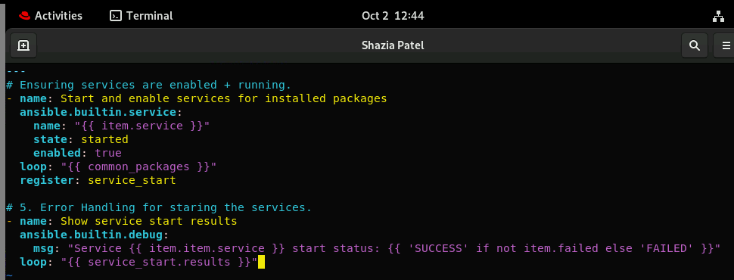
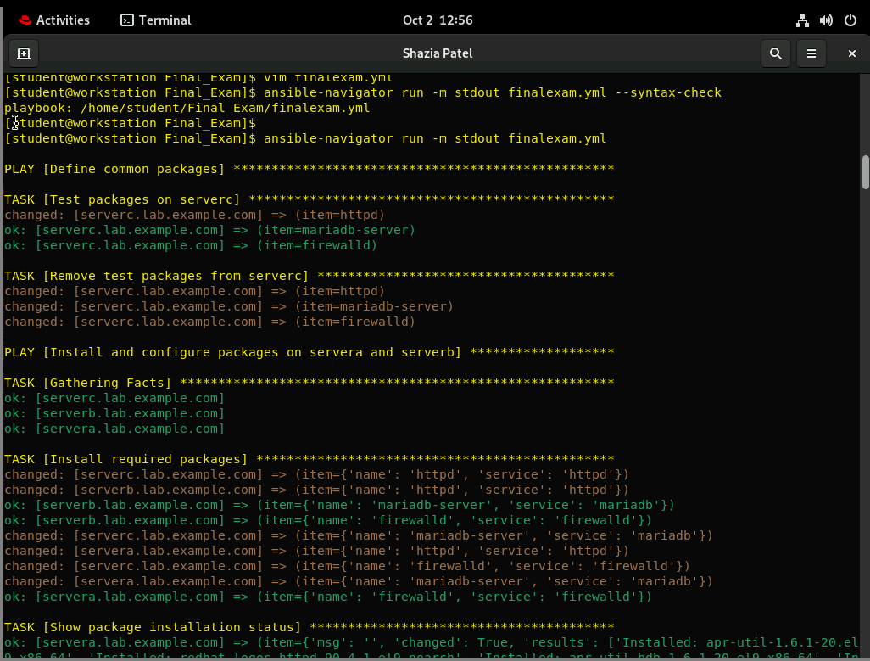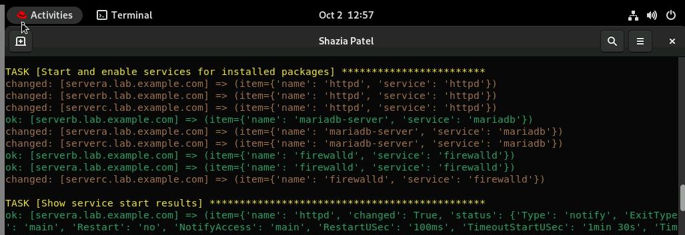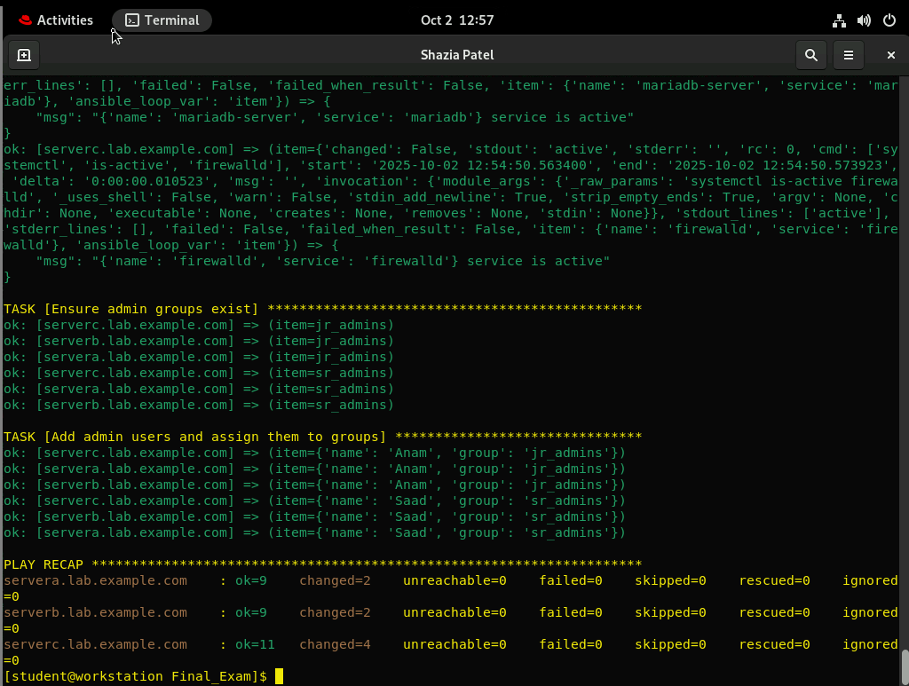

Testing with Modules
Some modules can provide additional information about the status of a managed host. The following list includes some Ansible modules that can be used to test and debug issues on managed hosts.
The ansible.builtin.uri module
Added the one more task at the bottom of main playbook

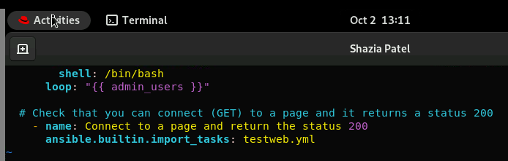
testweb.yml
